**Experiment No :** 07

**Experiment name :** Write a C programming for linear search

**Methodology :**

Linear search in C to find whether a number is present in an array. If it's present, then at what location it occurs. It is also known as a sequential search. It is straightforward and works as follows: we compare each element with the element to search until we find it or the list ends. Linear search for multiple occurrences and using a function

**Flow-Chart :**

Elements Present ?

Search element for nex position

Element found ?

Element not found

Element found

No

No

Yes

**Code :**

#include <stdio.h>

int main()

{

int array[100], search, c, n;

printf("Enter number of elements in array\n");

scanf("%d", &n);

printf("Enter %d integer(s)\n", n);

for (c = 0; c < n; c++)

scanf("%d", &array[c]);

printf("Enter a number to search\n");

scanf("%d", &search);

for (c = 0; c < n; c++)

{

if (array[c] == search) /* If required element is found */

{

printf("%d is present at location %d.\n", search, c+1);

break;

}

}

if (c == n)

printf("%d isn't present in the array.\n", search);

return 0;

}

**Output:**

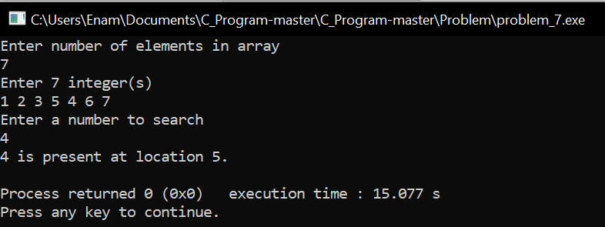

**Result discussion :**

Linear search is a method that searches for any number of objects in a linear way. Suppose there are 10 or 15 books in a bookshelf. I can tell by looking at the book that I am looking for. But if there are 1000 books in the shelf, I think it is random. If I can't find it, I have to find it from one direction, this is the operation of linear search